Ethernet bridging and making Access-Point act as a Router (Routing & Sharing)

In order to share the internet connection and make the Raspberry-Pi’s access-point (AP) act as a router for further sharing and routing internet information accordingly we need to perform following steps as mentioned below:

1. First of all insert the memory card in which Raspbian is pre-installed and now open the “boot” partition and open the “cmdline” txt file and insert the IP as: (navigate the end of the line and enter:

ip = 192.168.137.3



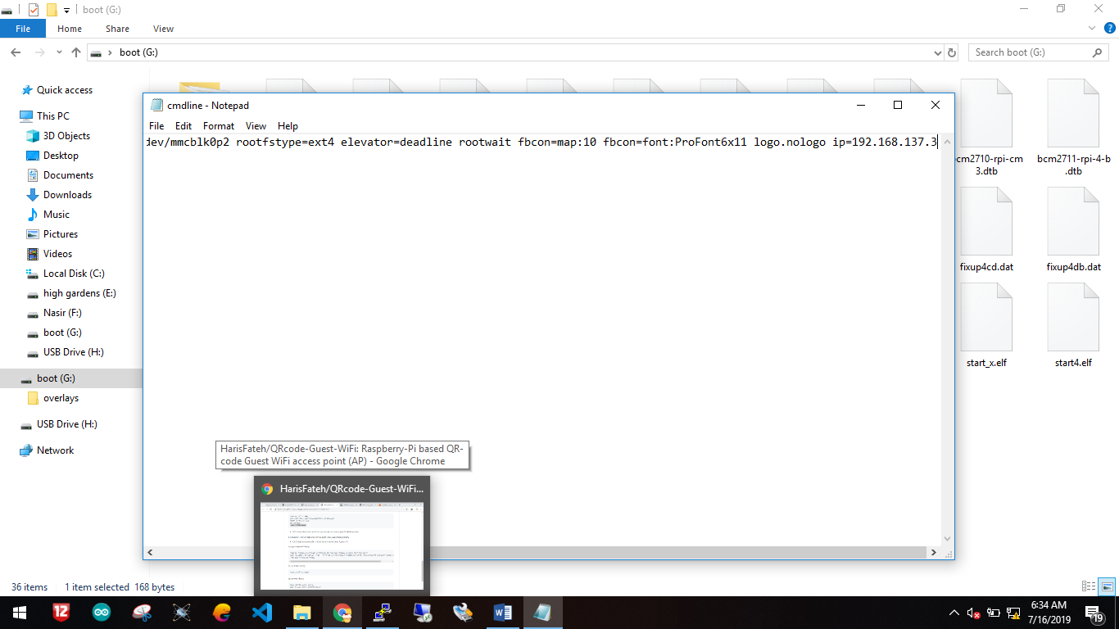

1. Connect the Raspberry-Pi with the Laptop or Computer (or any directly Ethernet internet connection in which you don’t require to go through these hectic steps, just plug in and play):
2. Next step is to open connect your computer or laptop with an internet connection via WiFi and share by opening the change adapter options and click on WiFi adapter and navigate to sharing tab as:

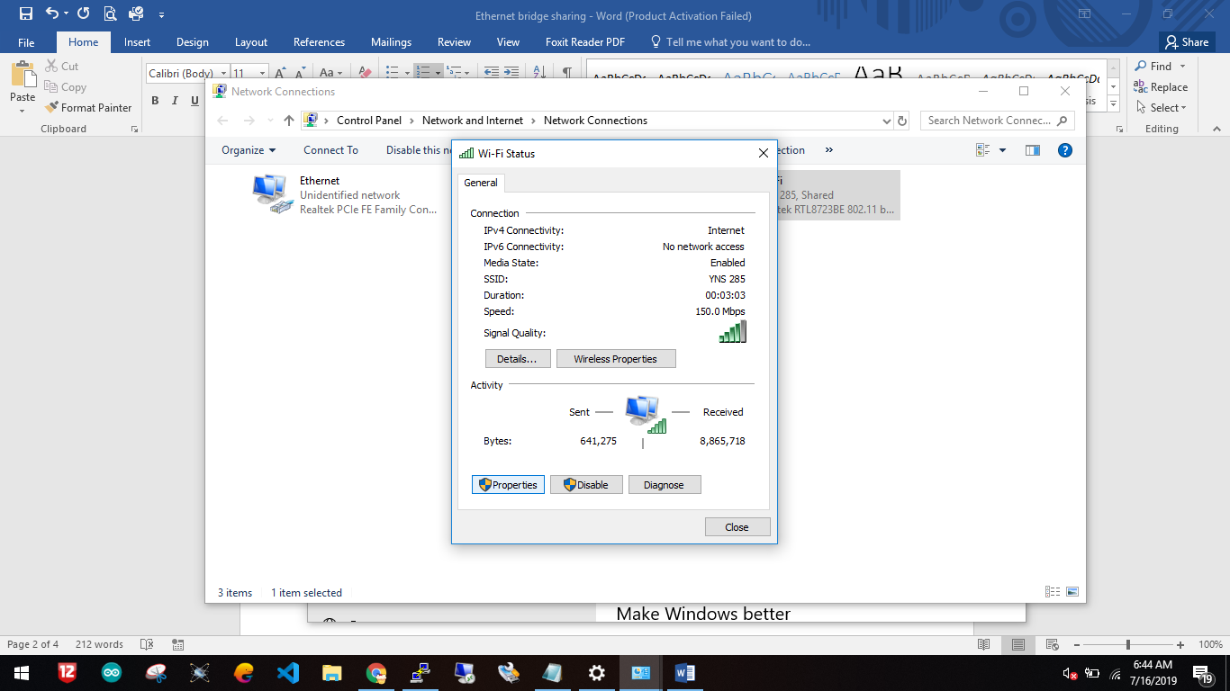

In addition, select Ethernet here for sharing as:

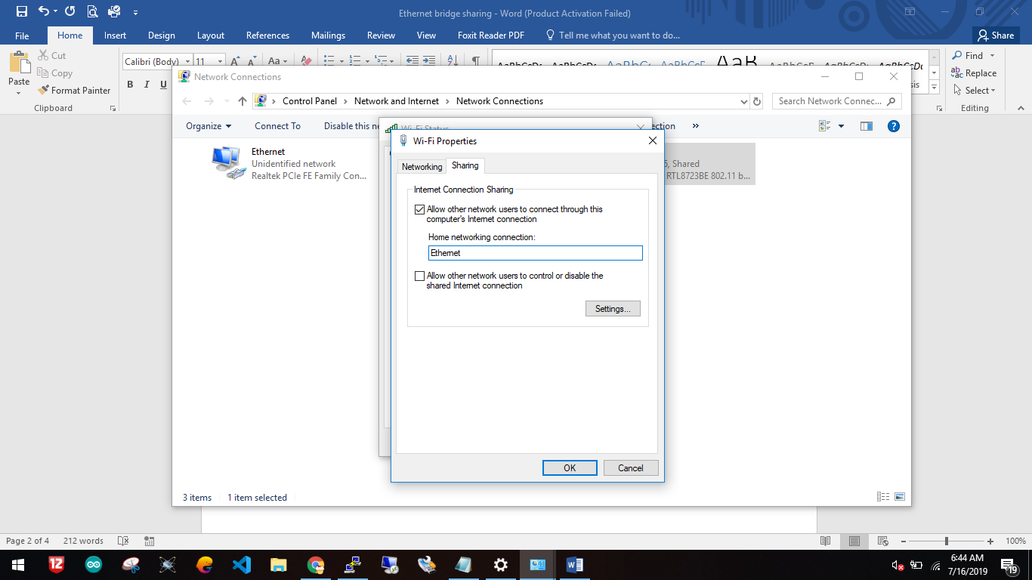

1. Now open the Ethernet adapter settings and navigate to IPv4 section and enter the following information as it is:

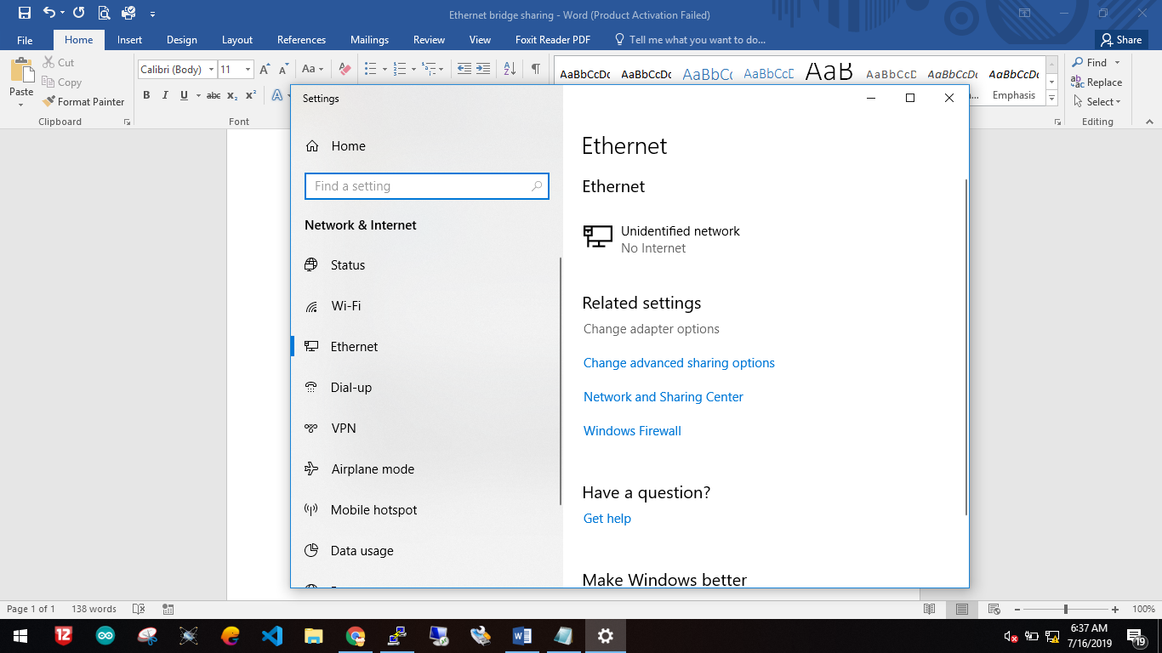

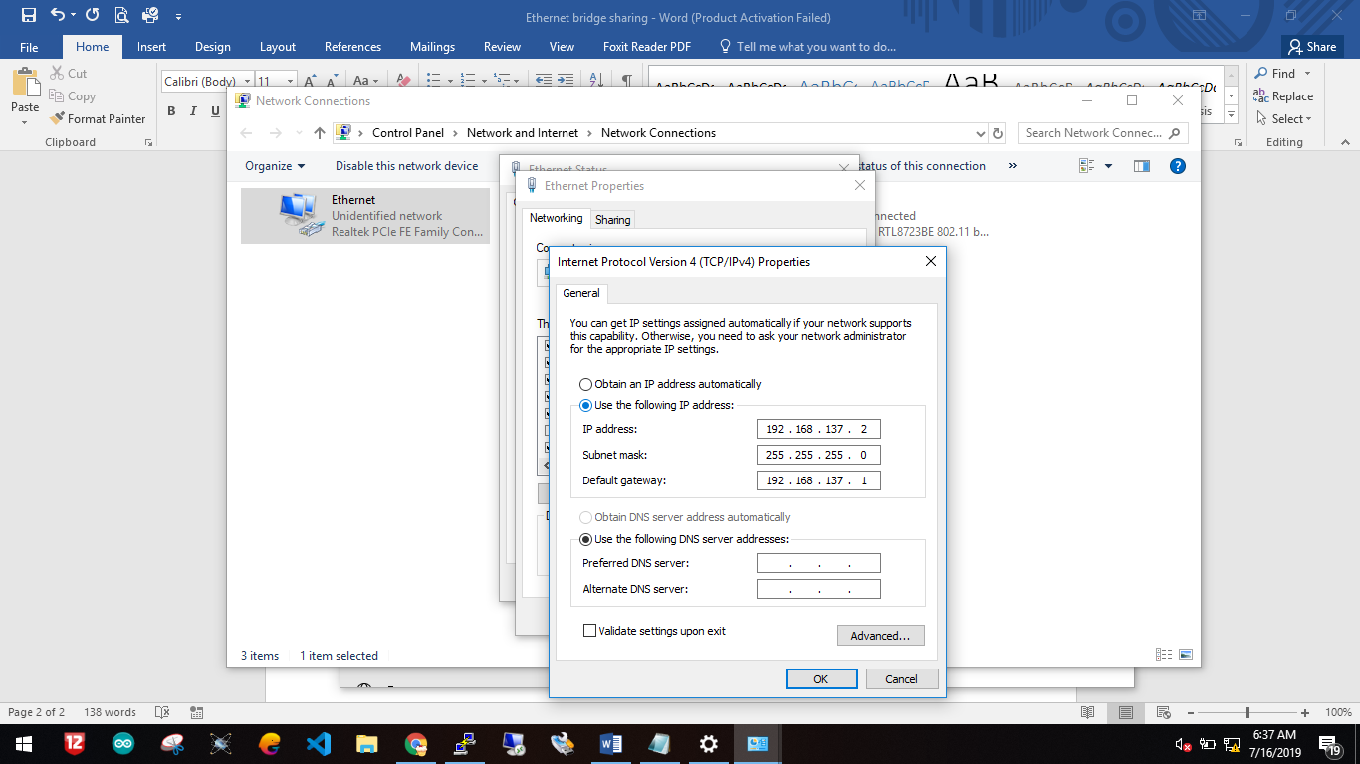

1. Now, open the Raspberry-Pi as “SSH” interfacing mode and you get the internet connection to the board without going to connect it via WiFi. This will allow you to make Raspberry-Pi as AP for internet connection sharing